UWC CHANGSHU CHINA

STUDENT HANDBOOK

PASSION PROJECT

THE UWCCSC FOUNDATION PROGRAMME

**Table of Contents:**

1. Passion Project Timeline
2. What is a Passion Project?
3. Aim of the Passion Project
4. Role of Supervisor
5. Passion Project and UWC Values
6. Passion Project and ATLs
7. Passion Project and Learner Profile
8. Passion Project and integration of Design Thinking
9. Passion Project and Interdisciplinary approach
10. Setting up a Goal (SMART goals)
11. Ideas for a good Passion Project
12. Project Process Journal
13. Uploading instructions for Managebac

|  |  |  |  |
| --- | --- | --- | --- |
| **Passion Project: Timeline** |  |  |  |
| Event | Date | Descriptions | Responsibility |
| PP Goal Form | 19-Oct | Filling in the survey | Students |
| Initial proposal submission | 9-Nov | Submission on Managebac | Students |
| 1st official meeting with P.P Supervisor | 13-17 November | Discussion on PP Proposal, 1st Reflection to be entered on Managebac, approval of proposal | Students and supervisors |
| Final Proposal Submission | 7-Dec | Completion and submission of Final proposal on Managebac | Students |
| 2nd official meeting with P.P Supervisor | 7-11 January | Receive feedback on your final project proposal and discuss how best to proceed with your project. Entering the Interim reflection of Managebac | Students and supervisors |
| 3rd official meeting with P.P. supervisor | 18-22 March | Focus on preparing for the research report | Students and Supervisors |
| 4th and Final meeting with P.P. supervisor | 15-19 April | Meeting for viva and Final reflection with supervisors | Students and Supervisors |
| Due date of project report | 22-Apr | To be submitted on Managebac | Students. Check by supervisors |
| Exhibition | 26-Apr | In library (After lunch) | Students. Judged by supervisors. |
| Final Marks due | 26-May | To be submitted electronically | Supervisors |

**P**

**ON PROJECTWhat is a Passion Project?**

A project of YOUR choice to practice and strengthen your research, presentation and organization skills; to consolidate prior and subject-specific learning; and to develop and demonstrate an area of PERSONAL INTEREST. It also prepares the students for essential components of the IB diploma programme.

The Passion Project is an integral part of the core of the Foundation Programme (FP) experience at UWCCSC and therefore it is expected that everybody will engage and complete the process. The process includes: conducting background research; writing a project proposal; creating a product; writing a written report; and presenting the findings at the PP Exhibition.

A Passion Project should have the following elements:

* The goal must be SMART (specific, measurable, achievable, relevant and time-bound)
* The PP must allow you to express a truly personal message/initiative
* It should be the result of your own initiative, creativity and ability to organise and plan
* The PP should reflect your special interests, hobbies, special abilities, or concerns about particular issues
* It must deal with a topic or area to which you are very interested in
* The PP should be entirely your own work—academic honesty is very important, and you will be required to sign a document stating that the II is your own work

A passion project **must not**:

* be part of any assessed course work
* take over your whole personal and social life, nor interfere with your other academic requirements, even though it will involve many hours of work

**Why do a Passion Project?**

* The PP will help you get prepared for the core components of the IB Diploma Programme; the Extended Essay (EE), Theory of Knowledge (TOK) and Creativity, Activity and Service (CAS)
* It will help you develop your research, writing and project management skills—all essential for your future educational aspirations and careers
* It will give you the opportunity to share with others something that is of great interest to you

**Aims**

The aims of the Passion Project are to allow you to:

* Demonstrate the personal abilities and skills required to produce and present an extended piece of work
* Engage in personal inquiry, action and reflection on specific topics and issues
* Reflect on learning and share knowledge, views and opinions

**Role of the supervisor**

A supervisor will advise you throughout the project, meet you on an appointed basis and make sure you complete the various stages of the project according to the deadlines set. You will be informed who your supervisor will be.

**You are responsible for setting up the schedule of meetings with your supervisor** and keeping a record of what takes place in your **process journal through ManageBac.** If you miss a meeting you will need contact the teacher to rearrange it.

**How will your supervisor help you?**

* Provide you with advice and guidance in the skills of undertaking research and ensures that your Passion Project is your own work
* Encourage and support you throughout the research and writing of the PP
* Discusses the choice of your topic
* Examines and gives feedback on the **Product**
* Reads and comments on one completed **Written Report**
* Takes in the reflection sessions with you
* Submits a grade for your Passion Project
* Conducts a viva voce with you to monitor the final grade

**What will your supervisor NOT do for you?**

* Choose your topic
* Find resources for you
* Provide you with detailed written feedback on your report
* Identify or correct grammar and spelling mistakes
* Tell you how to write your report
* Initiate communication/meetings with supervisees this must come from you
* Provide you with extensions of the due dates for your Passion Project

**Passion Project and UWC Values**

The Passion Project Intends to inculcate the UWC Values among the students of the Foundation Programme:

* International and intercultural understanding
* Celebration of difference
* Personal responsibility and integrity
* Mutual responsibility and respect
* Compassion and service
* Respect for the environment
* A sense of idealism
* PERSONAL CHALLENGE
* ACTION and personal example

**Passion Project and Approaches to Learning (ATLs)**

* **Communication Skills-** Improved through steps taken with various stakeholders, including PP supervisors at different stages of the development of the Passion Project
* **Collaboration Skills-** Encouraged through various collaborations undertaken during the journey of the PP
* **Self-management Skills-** These skills would be enhanced through proper organization of work and time, and through the process of reflection
* **Research Skills-** Using appropriate research methodology including information and media literacy and knowledge of acceptable methods of citations
* **Thinking Skills-** This would include creative and critical thinking within the framework of Design Thinking approach

**Passion Project and the IB learner profile**

The PP intends to also inculcate the IB learner profile in a UWCCSC FP student, which would enable them to be better prepared for the core elements of the IB Diploma Programme.

**Passion Project and integration of Design Thinking**

The passion project envisages to inculcate among the students the usage of the Design Thinking Cycle. Design Thinking [makes the best practices of agile development](https://think360studio.com/what-is-agile-ux-and-challenges-face-in-startup-product/), iterative development, user experience, creativity, prototyping and testing shine. It enforces a framework to deal with problems and stimulate innovation. Following are the stages of design thinking :-

# Empathize

Empathizing is central to the design thinking process. It highlights the significance of listening to the requirements and wants of our customers relative to the particular problem. The approach aids us in saving our discoveries and learnings during this stage in a systematic way such as empathy maps.

# Define

Here we combine all the insights collected at the time of listening and observing people. We start to synthesize and face the challenge ahead of us. That means we start to define a problem. An aspect that design thinking proves vital at is framing a problem in a clear manner so that we end up devising solutions and exploring opportunities. Try framing the problem correct so that more avenues and solutions open up.

# Ideate

So, now as the problem or the opportunity is clearly framed, we can search for methods to handle it. We should spur as many ideas as possible. Yes, we brainstorm or ideate. Design thinking stresses that during this phase we shouldn’t ignore ideas that seem obvious or easy. Any idea can sprout a brilliant concept. So, make sure to look into each and very idea with a fresh mindset.

Design thinking even encourages a team approach to brainstorming and very rightly promotes multi-disciplinary teams that bring across varied outlooks. This definitely produces better outcomes. To finalize this stage, we shortlist the best and leave the rest.

# Prototype

Prototyping brings the solutions into vision. Different methods are involved in it such as sketching, rapid prototyping and many others. No matter whatever method you opt, the core purpose of this stage remains the same, that is, we intend to create rough drafts of solutions to decide if these will prove beneficial for the problem.

As advised, follow a simple, speedy and economical approach while prototyping. Looking onto its context, a prototype can later transform into a beta product or a minimal viable product (MVP).

# Test

Next is testing. In this stage, we test our prototype with the customers so as to monitor the response and deem whether the solution satisfied them or not.

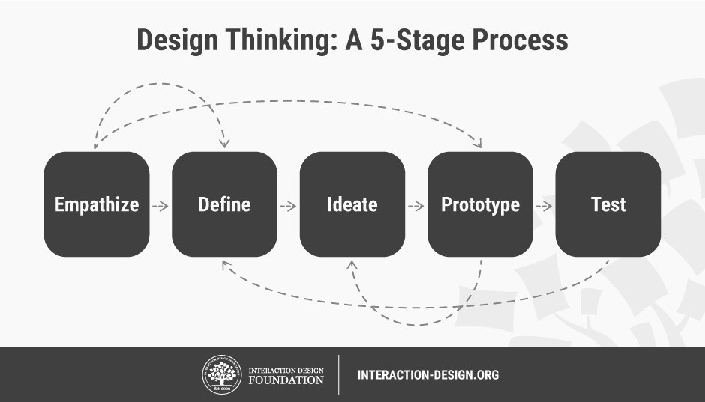

Source: <https://www.interaction-design.org/literature/article/5-stages-in-the-design-thinking-process>

**Passion Project and the Interdisciplinary Approach**

The students of the UWCCSC Foundation Programme (FP) would be expected to display the use of at least 2 different academic disciplines (subjects) while conducting research for their Passion Project. This would help them to effectively utilize knowledge of different disciplines in construction of their project and encourage them to undertake World Studies extended essay in the IB Diploma Programme.

**Setting up the Goal**

* All students are required to complete the Passion Project goal survey shared with them by the deadline as per the PP calendar.
* After completion of the survey results, students will be assigned a supervisor
* Students will then go on to complete the initial project proposal and upload it on Managebac by the deadline as per the PP calendar
* This will be followed by a mandatory meeting with the supervisors to discuss their proposals and seek approval. The first meeting with the supervisor should also be followed by the writing of the first reflection on Managebac by 17th of November, 2018
* Students are responsible for setting up these meetings with their supervisors within the specified deadline in the PP calendar
* The students are then required to upload their final proposals on Managebac as per the PP calendar deadline and meet supervisors within the stipulated time-frame to receive feedback and enter their Interim (second) reflection on Managebac

**Setting up a SMART goal:**

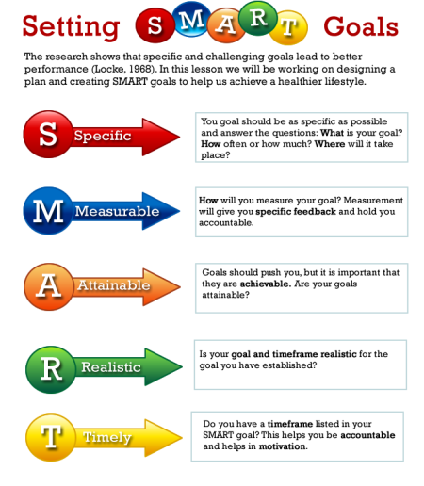

**Example of SMART goals:**

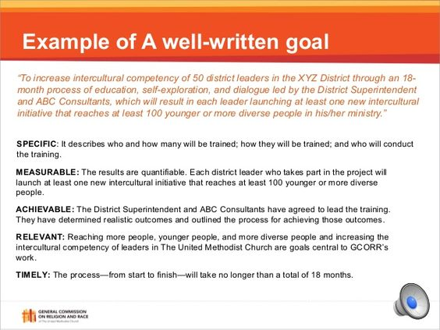

**Ideas for a good Passion Project**

* Culture and self-expression through dance at the local community arts centre; a performance, (Arts + Humanities)
* Nano fibres build stronger bikes; a prototype bike with nano fibres, Design and Physics (DT+Physics)
* Exploring the intersections (interactions) of race and inequality; a radio broadcast – design survey, collect secondary data, create and test the broadcast, broadcast within campus, (Physics + Geography)
* Building something - like a guitar, furniture, etc. , ideas for a furniture, research for requirements (DT+ Music/Art)
* Raising Awareness of Suzhou Embroidery and its history using Wechat as a platform (Art+History)
* Improvement of Laundry System at Residential Dorms at UWCCSC
* Using physics to perfect a sport (a pool shot, a hockey shot, a free-throw, etc.)

**Project Process Journal: Foundation Programme Passion Project**

* You are required to maintain a process journal, which should be updated regularly (using this document as a template) during the development of the investigation with 10-15 individual entries, and should be used to record progress honestly.
* Includes: thoughts, ideas, decisions, reactions, successes and failures.
* Can also include photographs, screen shots and other visual representations of the steps of your work (based on the type of project you have chosen to do).
* If you use/refer to any sources in your journal entry, include a ***citation*** & ***annotation*** at the end of the entry (MLA 8 style)
* The Process Journal will be recorded on ManageBac and backed up on a word document or written journal.
* Used in discussions with supervisors and to record these discussions. This will also help you to write your written report.

**EXAMPLE JOURNAL ENTRY**

**Sample 1:**

|  |
| --- |
| **Journal Entry Date: 7th November 2017** |
| **Topic/Focus**: (e.g., ‘Reading & Annotating primary source XX’ ‘Meeting with Supervisor’)  Meeting with architect of eco-friendly homes |
| **Main Entry** (thoughts, ideas, decisions, reactions, successes and failures): |
| Today I met with XX a well-recognized Architect in XX he has 30 years experience in the industry and specializes in Eco-friendly homes. He has been helpful by providing me with a source that gives me the context of how challenging it is to design cost-effective, sustainable energy storage systems in eco-friendly homes . (see citation and annotation below).  XX viewed my first designs and made the observation that I need to research a little more about the materials available in WA and to make decisions as to the rules of Eco-building that I am going to follow. He mentioned that every design project requires compromise and that I need to be clear on what aspects of Eco-design are most important to me. |
| **Reflection on learning & goals**: (What are your takeaways? Given what you learned, how should you move forward?) |
| After talking to XX, I realize that my design project is way too ambitious. Rather than trying to design an entire eco-house, I am going to focus on a particular aspect of an eco-house (such as the use of electric energy storage in low-cost eco-homes). I am going to do a literature review on the source he has given me and make modifications to my design based on my findings. |
| **Visual/Graphic Evidence** (try to embed all images here. If that is not possible, include them as separate attachments that are clearly labeled, and then write the full name of the file here (for your supervisor to find). |
| None today |
| **Sources Consulted** (include MLA 8 style **citation** and a 3-7 sentence long **annotation** explaining…   1. What kind of source is this (e.g., government report, essay, documentary)? 2. What info/data/ideas in this source are useful for my project and *why*? |

**Sample 2:**

**Entry - 26th June**

This entry is to mark the beginning of the summer break, and me starting work on Criteria B of the Passion Project. I have reached Kolkata and spoken to the expert I am due to meet over the course of the next few days to discuss my project. There are some difficulties, however, matching up our schedules to meet at times good for the both of us. I will try to spend as much time as possible on further working on my book, so that it does not become a concern for me around the end. It will be difficult to manage time, though, as I will also be busy completing homework and additional activities, but I will have to make it work.

Below is a graph meant to show how much time have spent on each task of Criteria A. I will further update this graph as I finish further criteria’s.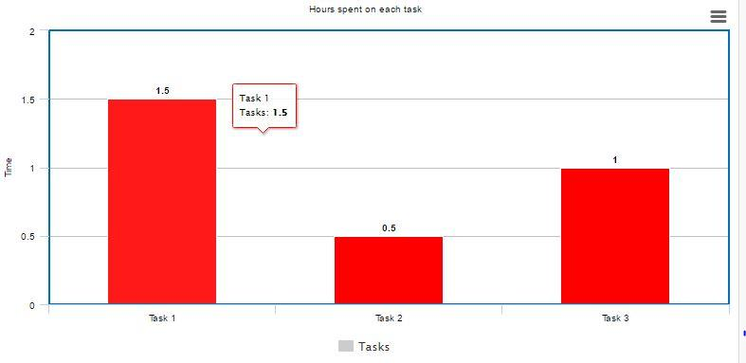

**Credits:**

1. <https://think360studio.com/what-is-design-thinking-and-design-thinking-process/> Accessed 10 October 2018
2. <https://medium.com/@ReigningIt/how-to-set-smart-goals-a-goal-setting-process-to-achieve-your-dreams-74015310c3dd> Accessed 10 October 2018
3. <http://alltemplate.me/imgs/> Accessed 10 October 2018
4. <https://www.iss.k12.nc.us/cms/lib4/NC01000579/Centricity/Domain/1282/MYP_ideas_for_products.pdf> Accessed 10 October 2018